BUSINESS PROBLEM QUERY AND SOLUTION

- What is the total loan issued?
Query : SELECT
COUNT(id) AS total_loan_application
FROM financial_loan;

Ans : -- 38567

- Month to Date Total Loan Applications?
Query :
SELECT
DISTINCT(YEAR(issue_date)) AS unique_year
FROM financial_loan;
Ans :- 4314

- find the total loan application month on month compare the current month to previous month. Month-over-Month loan applications (single year)
Query :
WITH previous_month_application AS (
SELECT
MONTH(issue_date) AS month_num,
COUNT(id) AS loan_application
FROM financial_loan
GROUP BY MONTH(issue_date)
)
SELECT
month_num,
loan_application,
LAG(loan_application) OVER(ORDER BY month_num) AS pm_loan_application,
ROUND(
(loan_application - LAG(loan_application) OVER(ORDER BY month_num)) * 100.0
/ NULLIF(LAG(loan_application) OVER(ORDER BY month_num), 0), 2
) AS pct_change
FROM previous_month_application
ORDER BY month_num;
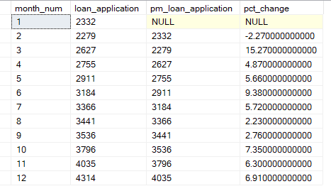

- Total Funded Amount
Query :
SELECT
SUM(loan_amount) AS total_funded_amount
FROM financial_loan;

Ans :
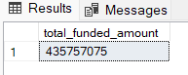

- What Total Amount funded to customer in each month ?
Query :
SELECT
MONTH(issue_date) AS months,
SUM(loan_amount) funded_amount
FROM financial_loan
GROUP BY MONTH(issue_date)
ORDER BY MONTH(issue_date);

Ans :
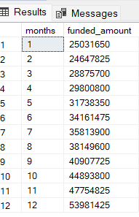
- What Previous Month to Date funded amount ?
Query : --
WITH previous_mtd_funded_amount AS (
SELECT
MONTH(issue_date) AS months,
SUM(loan_amount) AS funded_amount
FROM financial_loan
GROUP BY MONTH(issue_date)
)
SELECT
months,
funded_amount,
LAG(funded_amount) OVER(ORDER BY months) AS previous_month_funded_amount,
ROUND(
(funded_amount - LAG(funded_amount) OVER(ORDER BY months)) * 100.0
/ NULLIF(LAG(funded_amount) OVER(ORDER BY months), 0), 2
) AS pct_change
FROM previous_mtd_funded_amount
ORDER BY months;
Ans :
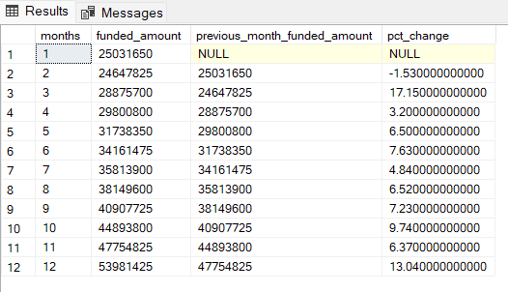

- What is the total amount received back by the customer?
Query :
SELECT
SUM(total_payment) total_amount_received
FROM financial_loan;
Ans :
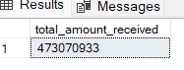

- What is the total amount received for each month?
Query :
SELECT
MONTH(issue_date) AS months ,
SUM(total_payment) total_amount_received
FROM financial_loan
GROUP BY MONTH(issue_date)
ORDER BY MONTH(issue_date);

Ans :---
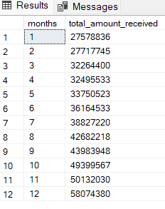
- What is Previous Month to Date received amount ?
Query :--
WITH previous_month_amount_received AS
(
SELECT
MONTH(issue_date) AS months ,
SUM(total_payment) total_amount_received
FROM financial_loan
GROUP BY MONTH(issue_date)

)
SELECT
months,
total_amount_received,
LAG(total_amount_received) OVER(ORDER BY months) AS previous_month_received_amount
FROM previous_month_amount_received;

Ans :--
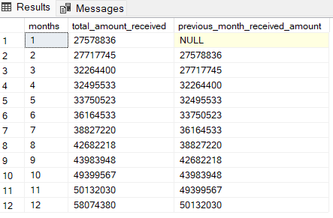

10 . What is the average interest rate ?
What is the average interest rate by month ?

Query :
SELECT
MONTH(issue_date) AS months,
CONCAT(ROUND(AVG(int_rate),4) * 100,'%') AS average_interest_rate
FROM financial_loan
GROUP BY MONTH(issue_date)
ORDER BY MONTH(issue_date);

Ans :
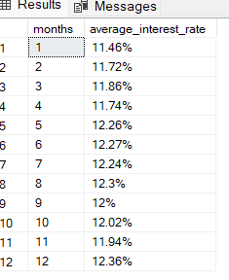

- What is Average Debt to Income ration by month ?
Query :
SELECT
MONTH(issue_date) AS months ,
YEAR(issue_date) AS years ,
CONCAT(ROUND(AVG(dti) * 100,2),'%') AS average_dept_to_income_ration
FROM financial_loan
GROUP BY MONTH(issue_date), YEAR(issue_date)
ORDER BY MONTH(issue_date);

Ans :
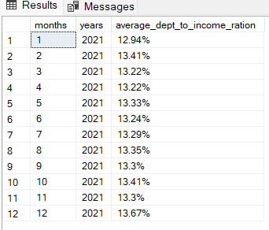

- Find the Good Loan Application vs Bad Loan Application?
Query :--
SELECT
CASE
WHEN loan_status IN ('Fully Paid', 'Current') THEN 'Good Loan'
ELSE 'Bad Loan'
END AS loan_category,
COUNT(*) AS application_count,
SUM(COUNT(*)) OVER() AS total_applications,
CAST(ROUND((COUNT(*) * 100.0) / SUM(COUNT(*)) OVER(), 2) AS DECIMAL(10,2)) AS pct_application
FROM financial_loan
GROUP BY
CASE
WHEN loan_status IN ('Fully Paid', 'Current') THEN 'Good Loan'
ELSE 'Bad Loan'
END;

Ans :--
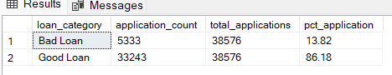

- What is the Good Loan Total Funded Amount?
Query :--
SELECT
SUM(loan_amount) AS good_loan_funded_amount
FROM financial_loan
WHERE loan_status IN ('Fully Paid', 'Current');

Ans :-
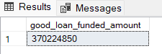
- Good Loan Received Amount?
Query :-
SELECT
SUM(total_payment) AS good_loan_received_amount
FROM financial_loan
WHERE loan_status IN ('Fully Paid', 'Current');

Ans :--
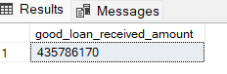

- What is the Total funded and Received amount for good loan?
Query :--
SELECT
SUM(loan_amount) AS good_loan_funded_amount,
SUM(total_payment) AS good_loan_received_amount,
SUM(total_payment) - SUM(loan_amount) AS profit_loss_amount
FROM financial_loan
WHERE loan_status IN ('Fully Paid', 'Current');

Ans :--
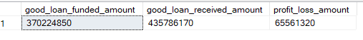

- Total Percentage of Bad Loans?
Query :--
SELECT
(COUNT(CASE WHEN loan_status = 'Charged Off' THEN id END) * 100 )
/ COUNT(id) AS bad_loan_pct_count
FROM financial_loan ;’

Ans :
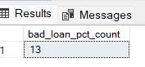

- What is total Bad Loans Applications?
Query :--
SELECT
COUNT(id) AS total_bad_loan_application
FROM financial_loan
WHERE loan_status = 'Charged Off';

Ans :--
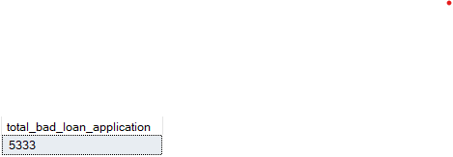

- What is total bad loan funded amount?
Query :--
SELECT
SUM(loan_amount) AS total_bad_loan_funded_amount
FROM financial_loan
WHERE loan_status = 'Charged Off';

Ans :--
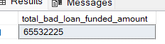

- Total Bad Loan Received Amount?
Query :--
SELECT
SUM(total_payment) AS total_bad_loan_received_amount
FROM financial_loan
WHERE loan_status = 'Charged Off';

Ans :-
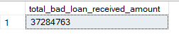

- What is Total Bad Loan funded amount vs Received Amount and Profit and loss?
Query :--
SELECT
SUM(loan_amount) AS total_bad_loan_funded_amount,
SUM(total_payment) AS total_bad_loan_received_amount,
SUM(total_payment) - SUM(loan_amount) AS profit_loss_amount
FROM financial_loan
WHERE loan_status = 'Charged Off';

Ans :--
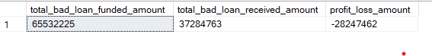

- Loan Status Grid View ?
Query :-
SELECT
loan_status ,
COUNT(id) AS LoanCount,
SUM(total_payment) AS Received_Amount,
SUM(loan_amount) AS Funded_Amount,
ROUND(AVG(int_rate)* 100,2) AS Intrest_Rate,
ROUND(AVG(dti) * 100,2) AS Debt_to_Income_Ratio
FROM financial_loan
GROUP BY loan_status;

Ans :--
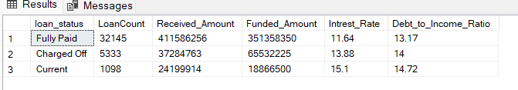

- Overall funded amount and received amount ?
Query :--
SELECT
SUM(loan_amount) AS Total_Funded_Amount,
SUM(total_payment) AS Total_Received_Amount,
SUM(total_payment) - SUM(loan_amount) AS profit_loss_amount
FROM financial_loan;

Ans:-
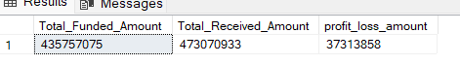

- Total Funded amount vs Received Amount by month by loan status ?
Query :--
SELECT
loan_status,
MONTH(issue_date) AS funded_received_amount_month,
SUM(loan_amount) AS funded_amount,
SUM(total_payment) AS received_amount
FROM financial_loan
GROUP BY loan_status, MONTH(issue_date)
ORDER BY MONTH(issue_date);
Ans :--
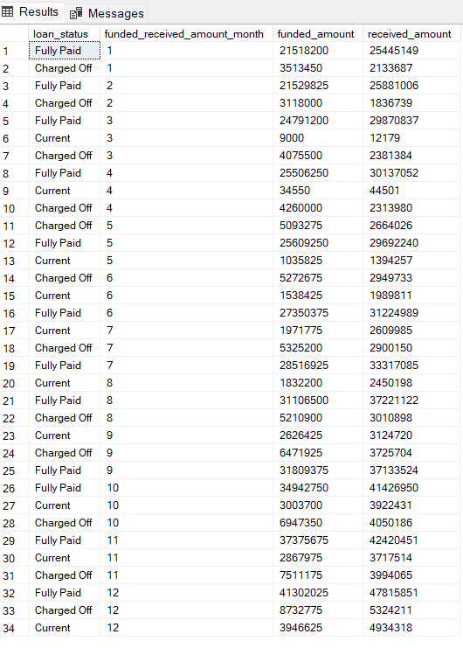

- What is Monthly rend by Issue Date ?
Query :--
SELECT
MONTH(issue_date) AS Month_Num,
DATENAME(MONTH, issue_date) AS Month_Name,
COUNT(id) AS Total_Loan_Application,
SUM(loan_amount) AS Total_Funded_Amount,
SUM(total_payment) AS Total_Received_Amount
FROM financial_loan
GROUP BY DATENAME(MONTH, issue_date),MONTH(issue_date)
ORDER BY MONTH(issue_date);

Ans :--
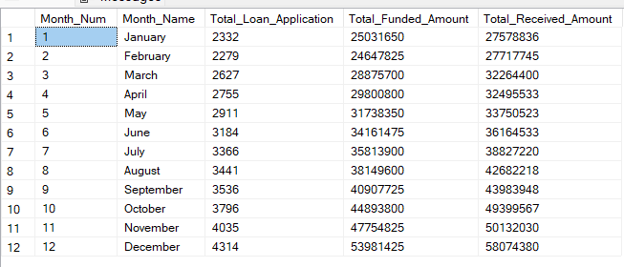

- Regional Sales Analysis ? Top 10?
Query :--
SELECT TOP 10
address_state,
COUNT(id) AS Total_Loan_Application,
SUM(loan_amount) AS Total_Funded_Amount,
SUM(total_payment) AS Total_Received_Amount
FROM financial_loan
GROUP BY address_state
ORDER BY Total_Funded_Amount DESC;

Ans :-
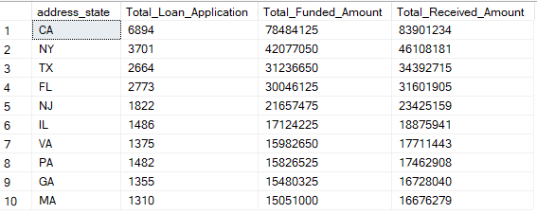
- Loan Term Analysis ?
Query :-
SELECT
term AS Term_In_Month,
CAST(LEFT(term, 2) AS INT) / 12 AS Term_In_Years,
COUNT(id) AS Total_Loan_Application,
SUM(loan_amount) AS Total_Funded_Amount,
SUM(total_payment) AS Total_Received_Amount
FROM financial_loan
GROUP BY term
ORDER BY Total_Funded_Amount DESC;

Ans :--

- Employee Length Analysis ?
Query :-
SELECT
emp_length,
COUNT(id) AS Total_Loan_Application,
SUM(loan_amount) AS Total_Funded_Amount,
SUM(total_payment) AS Total_Received_Amount
FROM financial_loan
GROUP BY emp_length
ORDER BY emp_length ;

Ans :--
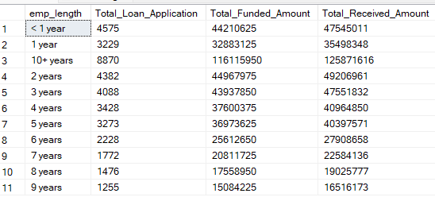

- Loan Purpose Analysis? Loan Purpose Breakdown.
Query :--
SELECT
purpose,
COUNT(id) AS Total_Loan_Application,
SUM(loan_amount) AS Total_Funded_Amount,
SUM(total_payment) AS Total_Received_Amount
FROM financial_loan
GROUP BY purpose
ORDER BY Total_Loan_Application DESC;

Ans :-
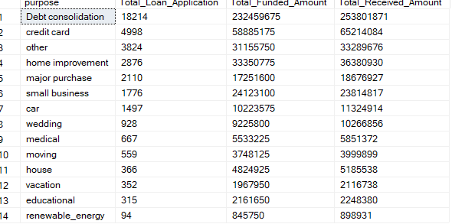

- Home ownership Analysis ?
Query :-
SELECT
home_ownership,
COUNT(id) AS Total_Loan_Application,
SUM(loan_amount) AS Total_Funded_Amount,
SUM(total_payment) AS Total_Received_Amount
FROM financial_loan
GROUP BY home_ownership
ORDER BY Total_Loan_Application DESC;

Ans:-

